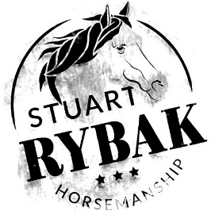
Stuart Rybak Horsemanship
[multi-day/single-day] Horsemanship Clinic
[dates]
[location]
[city, state]
[cost info]
[cost info]
[cost info]
We are pleased to announce that we have the honor of hosting Craig Cameron-certified trainer Stuart Rybak of Gainesville, TX, for an exciting horsemanship clinic here at [your location name]. Stuart has 20 years’ experience teaching clinics, working for Craig Cameron, Scott McCutcheon Reining, and Craig Johnson Reining. Stuart has twice judged The Extreme Mustang Makeover Events as well as judging The Extreme Cowboy Race World Show in 2014. Stuart is an effective trainer – both of horses and of people. All disciplines are welcome – English and Western –The emphasis of this clinic is on improving your horsemanship skills by focusing on better communication with your horse through the proper use of rider aids. Horses should be able to walk/trot/canter. Participants may bring as many horses as they choose – rider fee is the same and only additional stall fees will apply.
Stalls will be available on a limited basis for an additional fee of [enter amount here]/night – Owner to provide hay/grain.

Only [enter number of] participants will be accepted on a first come first serve basis. To secure your spot please send a [cost of deposit] nonrefundable deposit to:
[address line 1]
[address line 2]
[address line 3]
Checks should be made payable to [enter here]. Please include an email address and/or phone number with your deposit.
Please contact [contact name] at [email/phone] for more information

